StayEase Microservices Platform – Enterprise Architecture & Technical Documentation

1. Executive Summary

Project Name
Stay Ease – Hostel Management Platform

Project Type
Enterprise-grade distributed microservices-based backend platform for:
- Property listing management
- Owner onboarding
- User management
- Booking lifecycle management
- Online payment processing
- Notification delivery
- Secure authentication & authorization

Architectural Style
- Microservices Architecture
- RESTful API Design
- API Gateway Pattern
- Layered Architecture per Service
- Distributed Transaction Coordination (Partial Saga-style orchestration)

Technology Stack
Layer | Technology
Language | Java 21
Framework | Spring Boot 3.x
API Layer | Spring Web
Security | Spring Security + JWT
ORM | Spring Data JPA + Hibernate
Build Tool | Gradle
Communication | REST + OpenFeign
Database | MySQL
Payment Gateway | Razorpay
Documentation | Swagger / OpenAPI
Validation | Jakarta Validation
Logging | SLF4J / Logback
Async Processing | @Async + ThreadPoolTaskExecutor
Gateway | Spring Cloud Gateway

2. High-Level Solution Architecture
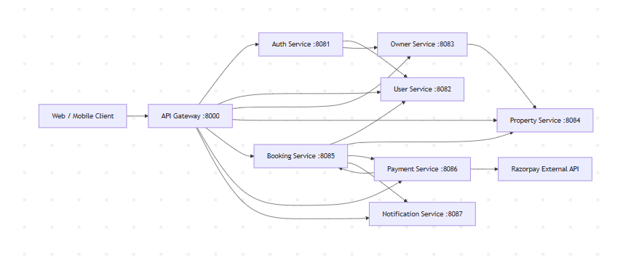

3. Microservices Inventory
Service | Port | Responsibility
API Gateway | 8000 | Centralized routing, security entry point
Auth Service | 8081 | Authentication, JWT token management
User Service | 8082 | User profile & wishlist management
Owner Service | 8083 | Property owner onboarding & KYC
Property Service | 8084 | Property, room & amenities management
Booking Service | 8085 | Booking lifecycle orchestration
Payment Service | 8086 | Razorpay payment integration
Notification Service | 8087 | Email/SMS notifications

4. API Gateway Architecture

Responsibilities
- Centralized request routing
- Security enforcement
- JWT validation entry point
- Cross-cutting concern management
- Single entry point for clients

Architectural Benefits
- Reduces direct exposure of internal services
- Simplifies frontend integration
- Enables centralized security policies
- Improves scalability and maintainability

Gateway Flow
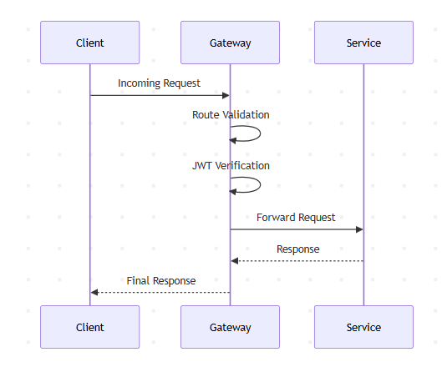

5. Authentication & Security Architecture

Security Model
StayEase uses JWT-based stateless authentication.

Authentication Flow
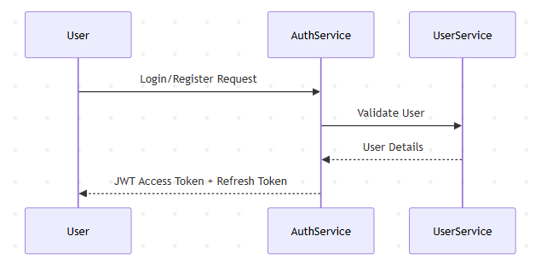

Implemented Security Features
- JWT Authentication
- Stateless Sessions
- Role-based authorization
- Password encryption
- Refresh token support
- Internal service communication protection
- Secure endpoint routing

Roles
Role | Responsibilities
USER | Booking and property browsing
OWNER | Property management
ADMIN (future scalable role) | Platform administration

6. Service-Wise Detailed Architecture

6.1 Auth Service

Responsibilities
- User registration
- User login
- JWT generation
- Refresh token handling
- Password management

Main APIs
API | Method | Purpose
/auth/register | POST | Register user/owner
/auth/login | POST | Authenticate user
/auth/refresh-token | POST | Generate new access token
/auth/change-password | POST | Change password

Internal Dependencies
- User Service
- Owner Service

Design Patterns Used
- DTO Pattern
- Service Layer Pattern
- Repository Pattern
- Exception Handling Pattern

6.2 User Service

Responsibilities
- User profile management
- Wishlist management
- Booking history retrieval

Main APIs
API | Method | Purpose
/users/{userid} | GET | Get user details
/users/update/{userid} | PUT | Update profile
/users/addwishlist/{userid} | POST | Add property to wishlist
/users/getwishlist/{userid} | GET | Retrieve wishlist
/users/getbookings/{userid} | GET | Retrieve bookings

Key Features
- User profile maintenance
- Wishlist tracking
- Booking association handling

6.3 Owner Service

Responsibilities
- Owner onboarding
- KYC verification
- Owner property aggregation

Main APIs
API | Method | Purpose
/owners/getowner/{ownerId} | GET | Fetch owner details
/owners/kyc/{ownerId} | PUT | Update KYC status
/owners/property-internal/properties/{ownerId} | GET | Retrieve owner properties

Architectural Observations
- Separate owner domain improves domain isolation
- Supports future enterprise scaling
- Enables independent compliance workflows

6.4 Property Service

Responsibilities
- Property management
- Room inventory management
- Amenities management
- Availability handling

Main APIs

Property APIs
API | Method | Purpose
/properties/addproperty | POST | Add new property
/properties/{propertyId} | GET | Get property
/properties/{propertyId} | PUT | Update property
/properties/owner/{ownerId} | GET | Owner properties

Room APIs
API | Method | Purpose
/properties/rooms/addroom/{propertyId} | POST | Add room
/properties/rooms/getroom/{propertyId} | GET | Retrieve rooms
/properties/rooms/reserverroom/{roomId} | PUT | Reserve room
/properties/rooms/releaseroom/{roomId} | PUT | Release room
/properties/rooms/availability/{roomId} | GET | Room availability

Amenity APIs
API | Method | Purpose
/amenities/createamenity | POST | Add amenity
/amenities/getallamenities | GET | List amenities
/amenities/link/{propertyId} | POST | Link amenities

Core Domain Components
- Property
- Room
- Amenity
- Availability Status

6.5 Booking Service

Responsibilities
- Booking orchestration
- Booking lifecycle management
- Payment coordination
- Notification triggering
- Room reservation coordination

Main APIs
API | Method | Purpose
/bookings/createbooking | POST | Create booking
/bookings/getbooking/{bookingId} | GET | Fetch booking
/bookings/cancelbooking/{bookingId} | PUT | Cancel booking
/bookings/status/{bookingId} | PUT | Update booking status
/bookings/{bookingId}/confirm | PUT | Confirm booking
/bookings/{bookingId}/fail | PUT | Fail booking

Service Integrations
- User Service
- Property Service
- Payment Service
- Notification Service

Booking Lifecycle
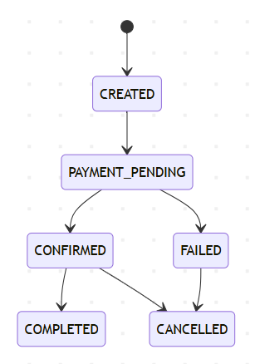

Orchestration Flow
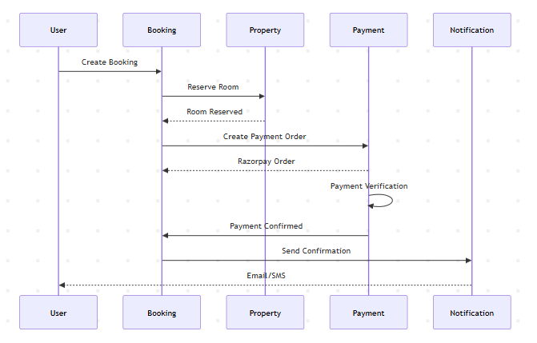

Architectural Strengths
- Centralized business orchestration
- Clear transaction boundaries
- Strong separation of concerns
- Supports eventual consistency

6.6 Payment Service

Responsibilities
- Razorpay integration
- Payment order creation
- Payment verification
- Refund processing
- Webhook handling
- Audit logging

Main APIs
API | Method | Purpose
/payments/order | POST | Create payment order
/payments/confirm | POST | Confirm payment
/payments/webhook | POST | Razorpay webhook
/payments/refund | POST | Initiate refund
/payments/refund/{refundId}/process | POST | Process refund

External Integration
- Razorpay APIs

Payment Workflow
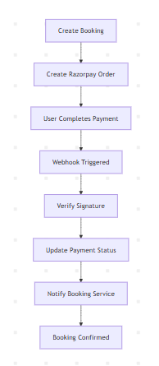

Enterprise Features Identified
- Webhook support
- Audit log structure
- Retry mechanisms
- Payment confirmation workflows
- Refund processing
- Resilience handling

6.7 Notification Service

Responsibilities
- Email notifications
- Async notification delivery
- Booking confirmation alerts
- Payment notification handling

Main APIs
API | Method | Purpose
/notifications/send | POST | Send notification

Technical Features
- Async processing
- Thread pool executor
- Decoupled notification handling
- Extensible communication layer

Async Notification Flow
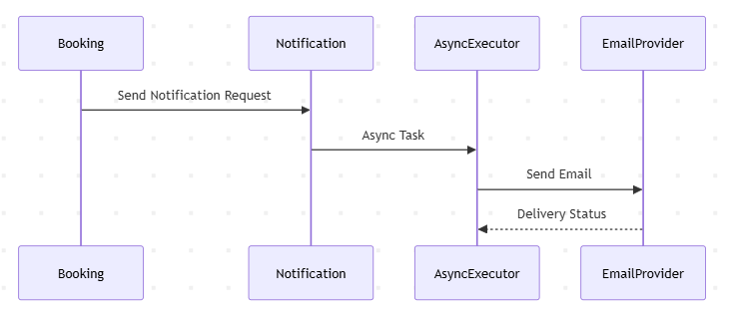

7. Inter-Service Communication Architecture

Communication Mechanism
- REST APIs
- OpenFeign Clients

Feign Integrations Identified
Source Service | Target Service
Auth Service | User Service
Auth Service | Owner Service
Booking Service | User Service
Booking Service | Property Service
Booking Service | Payment Service
Booking Service | Notification Service
Owner Service | Property Service
Payment Service | Booking Service

Advantages
- Loose coupling
- Independent deployments
- Scalable communication model
- Easy service discoverability adaptation in future

8. Database Architecture

Current Database Strategy
Database-per-service pattern.
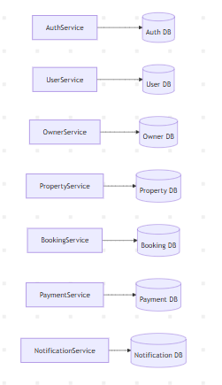

Advantages
- Strong service isolation
- Independent scaling
- Better fault isolation
- Independent schema evolution

9. Layered Architecture Pattern
Each microservice follows layered architecture.
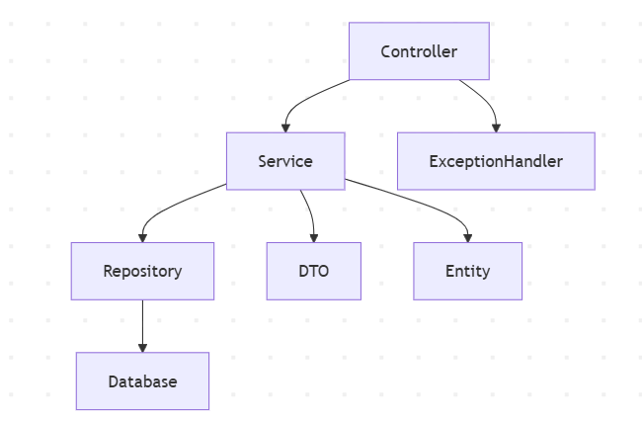

Layers

Controller Layer
- REST endpoint exposure
- Request validation
- Response handling

Service Layer
- Business logic orchestration
- Transaction management
- Integration handling

Repository Layer
- Database interaction
- JPA repository abstraction

DTO Layer
- Request/response abstraction
- Domain decoupling

Exception Layer
- Centralized exception handling
- Consistent API responses

10. Exception Handling Strategy

Pattern Used
Global Exception Handling using:
- @ControllerAdvice
- Custom Exceptions
- Standardized API Responses

Benefits
- Centralized error management
- Consistent client responses
- Better debugging support
- Improved maintainability

11. Logging & Monitoring Design

Logging Strategy
- SLF4J logging abstraction
- Structured service logs
- Error tracing
- Payment audit logs

Recommended Production Enhancements
Area | Recommendation
Centralized Logging | ELK Stack
Monitoring | Prometheus + Grafana
Tracing | Zipkin / Jaeger
Alerting | AlertManager

12. Scalability Characteristics

Horizontal Scalability
Each service can scale independently.
Example:
- Booking Service can scale during peak booking periods
- Notification Service can scale independently for email load
- Payment Service can scale during transaction spikes

Scalability Strengths
- Independent deployments
- Independent database scaling
- Stateless services
- JWT-based security
- Async processing support

13. Resilience & Reliability Analysis

Implemented Reliability Features
- Retry mechanisms
- Async processing
- Payment webhook verification
- Transaction boundaries
- Booking status tracking
- Room reservation handling

Recommended Enterprise Enhancements
Area | Recommendation
Circuit Breaker | Resilience4j
Distributed Tracing | OpenTelemetry
Message Broker | Kafka / RabbitMQ
Service Discovery | Eureka / Consul
Config Management | Spring Cloud Config
Containerization | Docker
Orchestration | Kubernetes

14. Deployment Architecture (Recommended)
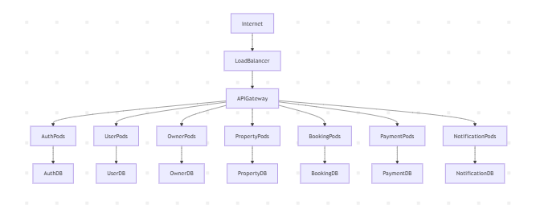

15. API Design Standards

REST Standards Followed
- Resource-based URIs
- HTTP verb semantics
- JSON payloads
- Status code handling
- Layered DTOs

Status Codes
Code | Meaning
200 | Success
201 | Created
400 | Bad Request
401 | Unauthorized
404 | Not Found
500 | Internal Server Error

16. Domain Model Overview
classDiagram
class User {
Long userId
String name
String email
String password
}
class Owner {
Long ownerId
String kycStatus
}
class Property {
Long propertyId
String propertyName
String location
}
class Room {
Long roomId
Boolean available
}
class Booking {
Long bookingId
BookingStatus status
}
class Payment {
Long paymentId
String razorpayOrderId
PaymentStatus status
}
User --> Booking
Owner --> Property
Property --> Room
Booking --> Payment
Property --> Amenity

17. Sequence Diagram – End-to-End Booking Journey
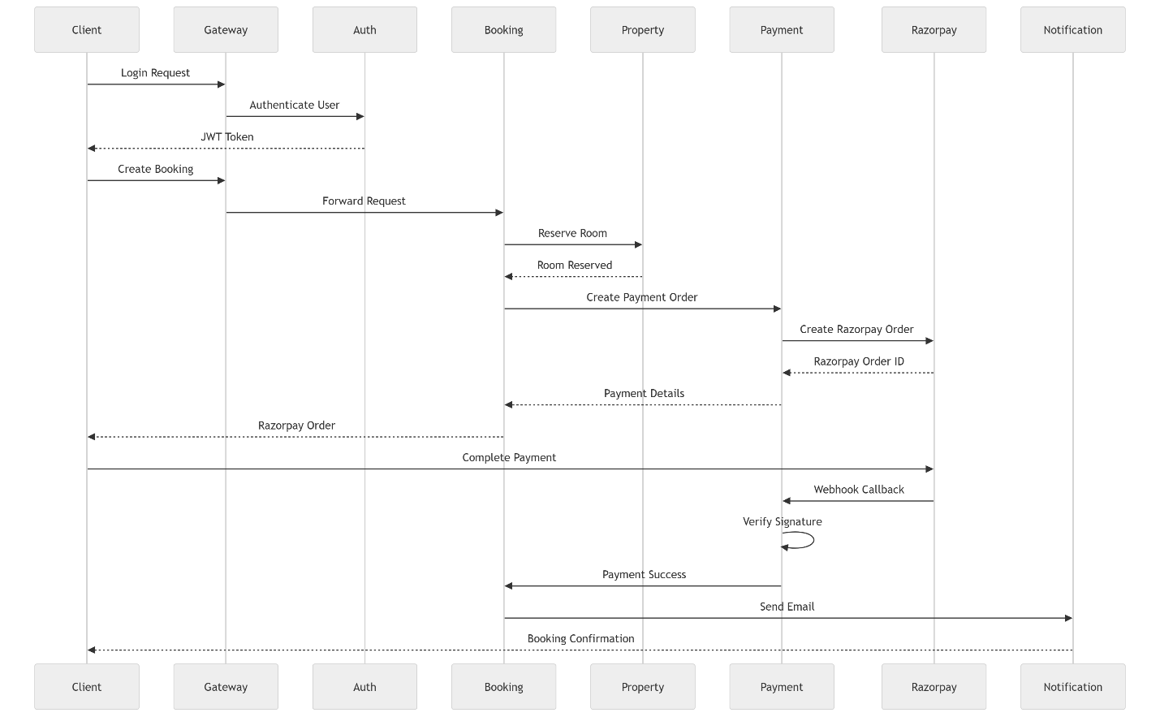

18. Architectural Design Patterns Used
Pattern | Usage
API Gateway Pattern | Centralized routing
Microservices Pattern | Distributed services
Layered Architecture | Internal service design
DTO Pattern | Request/response separation
Repository Pattern | Persistence abstraction
Service Pattern | Business logic encapsulation
Circuit Isolation | Service separation
Async Processing | Notification execution
Saga-like Orchestration | Booking-payment coordination

19. Production Readiness Assessment

Strong Areas
- Clear service separation
- Enterprise-style layering
- JWT security
- External payment integration
- Async processing
- Retry mechanisms
- Webhook handling
- RESTful API design
- Feign-based communication

Areas for Future Enterprise Maturity
- Kafka event-driven architecture
- Distributed tracing
- Centralized configuration
- API rate limiting
- Kubernetes deployment
- CI/CD pipelines
- Centralized observability
- Contract testing
- API versioning

20. CI/CD Pipeline Recommendation

21. Suggested Non-Functional Requirements
Category | Requirement
Availability | 99.9%
Scalability | Horizontal scaling
Security | JWT + HTTPS
Reliability | Retry & webhook verification
Performance | Async notification processing
Maintainability | Layered microservices
Extensibility | Independent service deployment

22. Technical Interview / Team Lead Demo Talking Points

Key Highlights to Explain

1. Why Microservices?
- Independent deployment
- Independent scalability
- Domain isolation
- Better maintainability

2. Why API Gateway?
- Single entry point
- Security centralization
- Routing abstraction

3. Why JWT?
- Stateless authentication
- Better scalability
- Reduced session dependency

4. Why Separate Payment Service?
- Financial domain isolation
- Security separation
- Easier auditing
- Retry management

5. Why Async Notifications?
- Faster booking response
- Reduced user wait time
- Improved throughput

6. How Consistency Is Managed?
- Booking lifecycle states
- Payment confirmation callbacks
- Room reservation handling
- Retry mechanisms

7. Enterprise Concepts Demonstrated
- Distributed architecture
- External integrations
- Resilience handling
- Layered design
- DTO abstraction
- API orchestration

23. Future Enhancements Roadmap

Phase 1
- Dockerization
- Kubernetes deployment
- Centralized logging
- Service discovery

Phase 2
- Kafka integration
- Event-driven architecture
- Distributed tracing
- Observability dashboards

Phase 3
- AI recommendations
- Dynamic pricing engine
- Search optimization
- Multi-region deployment

24. Final Architecture Evaluation

Overall Architectural Rating
Area | Rating
Modularity | Excellent
Scalability | Strong
Maintainability | Strong
Security | Good
Resilience | Good
Extensibility | Excellent
Enterprise Readiness | Strong Intermediate Enterprise Level

Final Assessment
StayEase demonstrates strong enterprise backend engineering principles with:
- Proper domain-driven microservice separation
- Payment orchestration
- Secure authentication
- Async processing
- API gateway routing
- Layered architecture
- External system integration
- Transaction lifecycle management
The project is highly suitable for:
- Enterprise backend demonstrations
- Senior Java/Spring Boot interviews
- Team lead architecture discussions
- FinTech/TravelTech style backend showcases
- Production-grade learning portfolios

25. Suggested Demo Flow

Recommended Demo Sequence
- Explain overall architecture diagram
- Show API Gateway routing
- Demonstrate authentication flow
- Register/login user
- Add property as owner
- Add rooms & amenities
- Create booking
- Trigger payment order
- Demonstrate webhook confirmation
- Show notification flow
- Explain resilience/retry logic
- Explain layered architecture
- Explain future scalability approach

26. Complete Feign Client Integration Architecture

Feign Communication Overview
StayEase uses OpenFeign for synchronous inter-service communication between microservices.
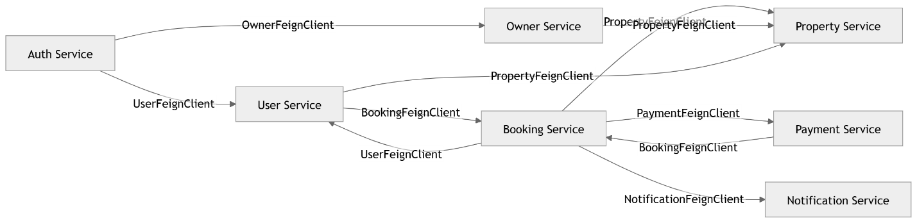

Complete Feign Client Matrix
Source Service | Feign Client | Target Service | Purpose
Auth Service | UserFeignClient | User Service | User validation
Auth Service | OwnerFeignClient | Owner Service | Owner onboarding
Booking Service | UserFeignClient | User Service | Fetch user details
Booking Service | PropertyFeignClient | Property Service | Room reservation
Booking Service | PaymentFeignClient | Payment Service | Payment initiation
Booking Service | NotificationFeignClient | Notification Service | Send notifications
Owner Service | PropertyFeignClient | Property Service | Owner properties
Payment Service | BookingFeignClient | Booking Service | Booking confirmation

End-to-End Booking + Payment + Notification Flow


27. Enterprise-Level ER Diagram

Core Entity Relationship Diagram

28. End-to-End Enterprise Architecture Diagram
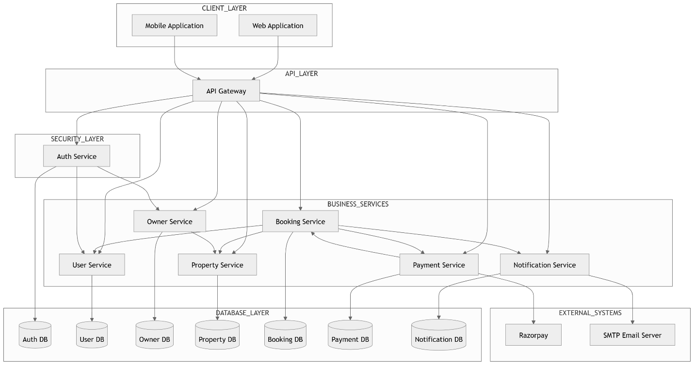

29. Detailed Component Architecture Diagram
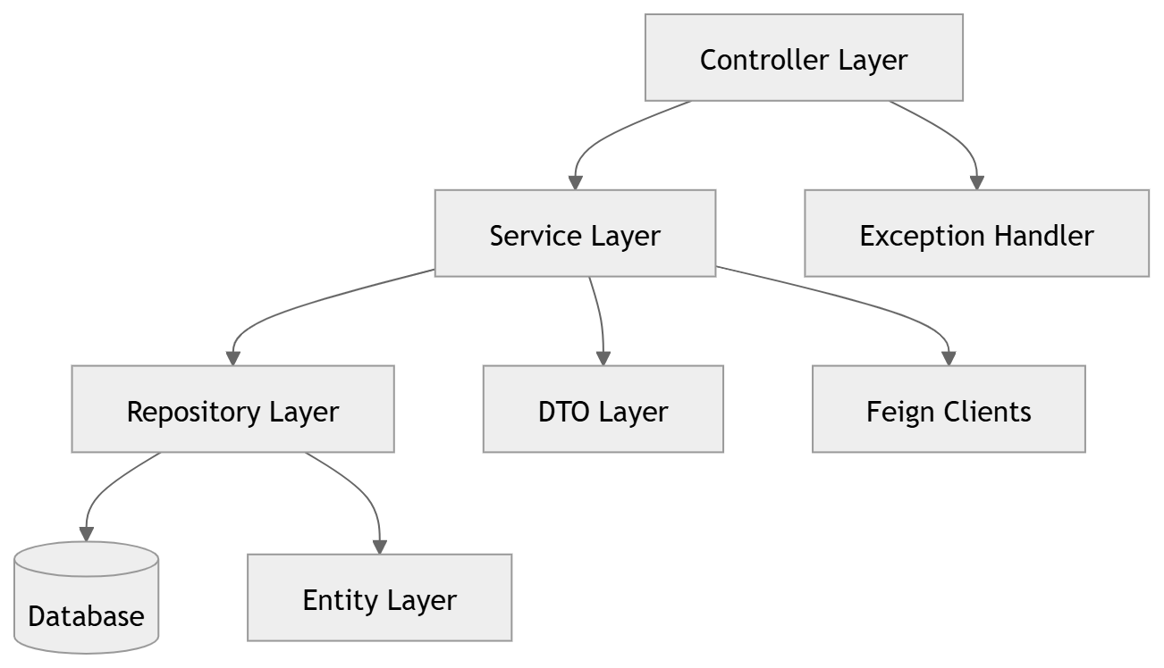

30. Distributed Transaction Coordination Flow
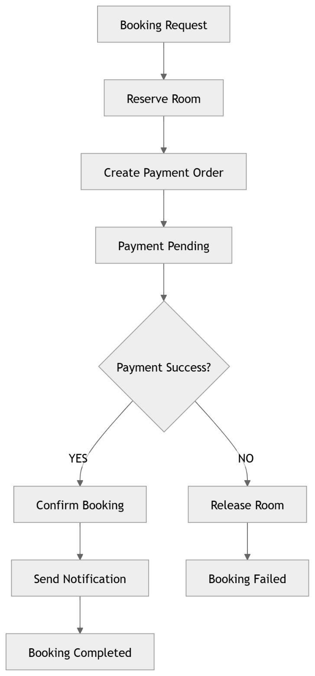

31. Production-Grade Infrastructure Architecture

32. Complete Feign Configuration Analysis (Code-Level)

Shared Feign Architecture Pattern Used Across Services
Your project follows a standardized enterprise Feign integration architecture.
Each microservice contains:
- FeignClientConfig
- FeignErrorDecoder
- FeignLoggingConfig
- Dedicated Feign Clients
- Authorization Header Propagation
- Correlation ID Propagation
- Centralized Error Translation

32.1 Request Interceptor Architecture

Common Enterprise Pattern Implemented
All services propagate:
- Authorization Header
- X-Correlation-Id
This is an enterprise-grade distributed tracing and security propagation mechanism.

Flow
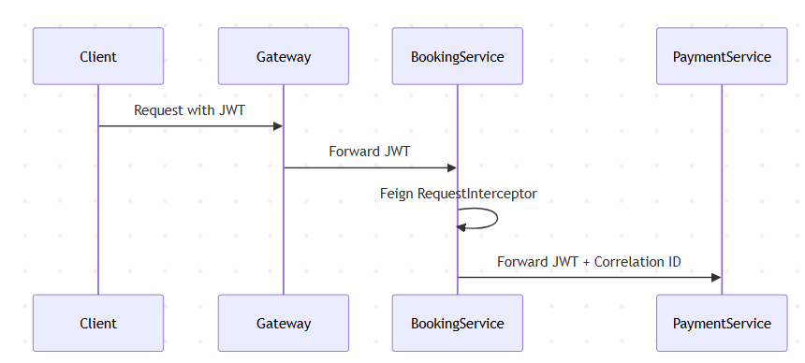

32.2 Auth Service Feign Integration

Enable Feign
@EnableFeignClients

Feign Clients
Client | Target | Endpoint
UserClientConfig | User Service | /users/auth-internal
OwnerClient | Owner Service | /owners/auth-internal

Feign URLs
Property
services.user-service.url
services.owner-service.url

Enterprise Features Present
- JWT propagation
- Correlation tracing
- FULL request logging
- Centralized downstream exception handling

32.3 Booking Service Feign Integration

Enable Feign
@EnableFeignClients(basePackages = "com.stayease")

Feign Clients
Client | Target Service | Endpoint Purpose
UserClient | User Service | User validation/details
PropertyClient | Property Service | Room reservation
PaymentClient | Payment Service | Payment order creation
NotificationClient | Notification Service | Booking notification

Booking Service = Central Orchestrator
Your Booking Service acts as the orchestration engine.
This is architecturally significant because:
- It coordinates distributed transactions
- It manages booking lifecycle
- It synchronizes room + payment + notifications
- It handles business workflow state transitions

Feign Flow

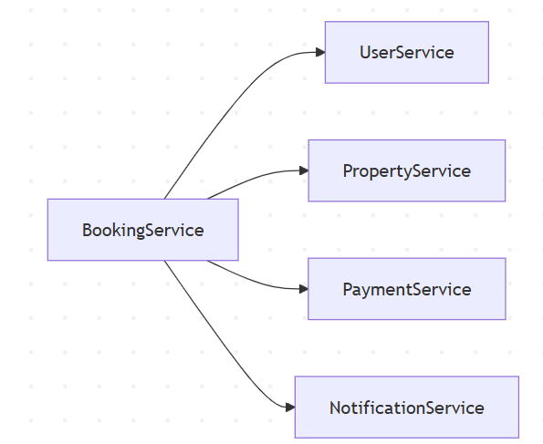Advanced Features Identified
- Custom BusinessException mapping
- Conflict handling (409)
- Service unavailable handling (503)
- Distributed tracing support
- Authorization forwarding
- Full Feign request logging

32.4 Property Service Feign Integration

Feign Client
Client | Target | Purpose
OwnerClient | Owner Service | KYC validation

APIs Used
Endpoint
/owners/owners-internal/{ownerId}
/owners/owners-internal/kyc-status/{ownerId}

Architectural Importance
Property creation depends on:
- Owner validation
- KYC verification
This demonstrates:
- Domain security isolation
- Compliance-aware architecture
- Owner validation workflow

32.5 User Service Feign Integration

Feign Clients
Client | Target | Purpose
BookingClient | Booking Service | Booking history
PropertyClient | Property Service | Wishlist property details

Endpoints
Endpoint
/bookings/user/{userId}
/properties/{propertyId}

Business Capabilities
- Booking aggregation
- Wishlist enrichment
- Cross-service profile composition

32.6 Payment Service Feign Integration

Feign Clients
Client | Target | Purpose
BookingServiceClient | Booking Service | Booking confirmation
RazorpayClient | Razorpay API | External payment integration

Architectural Significance
This is a hybrid integration architecture:
- Internal microservice communication
- External third-party integration

Payment Flow

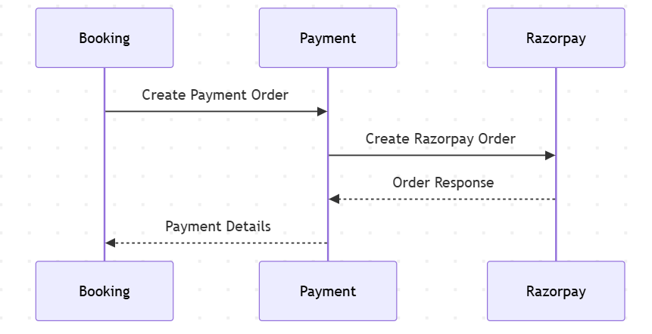Enterprise Features
- Webhook processing
- External API abstraction
- Payment verification
- Audit log integration
- Retry support

32.7 Owner Service Feign Integration

Feign Client
Client | Target | Purpose
PropertyClient | Property Service | Owner property retrieval

Business Role
Owner Service acts as:
- Owner domain manager
- Aggregator for owner assets

33. Service-Wise ER Diagrams

33.1 Auth Service ER Diagram
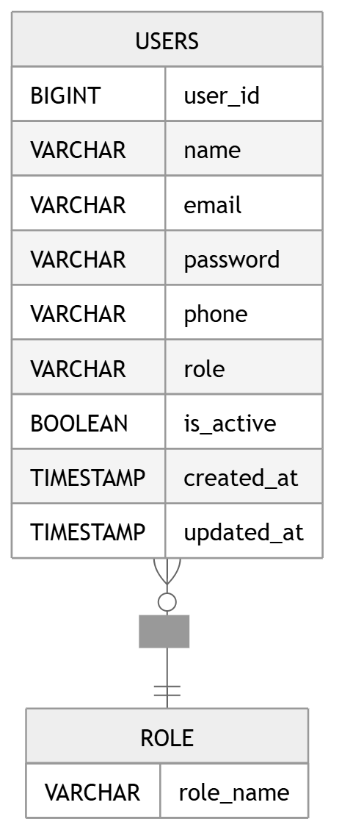

33.2 User Service ER Diagram
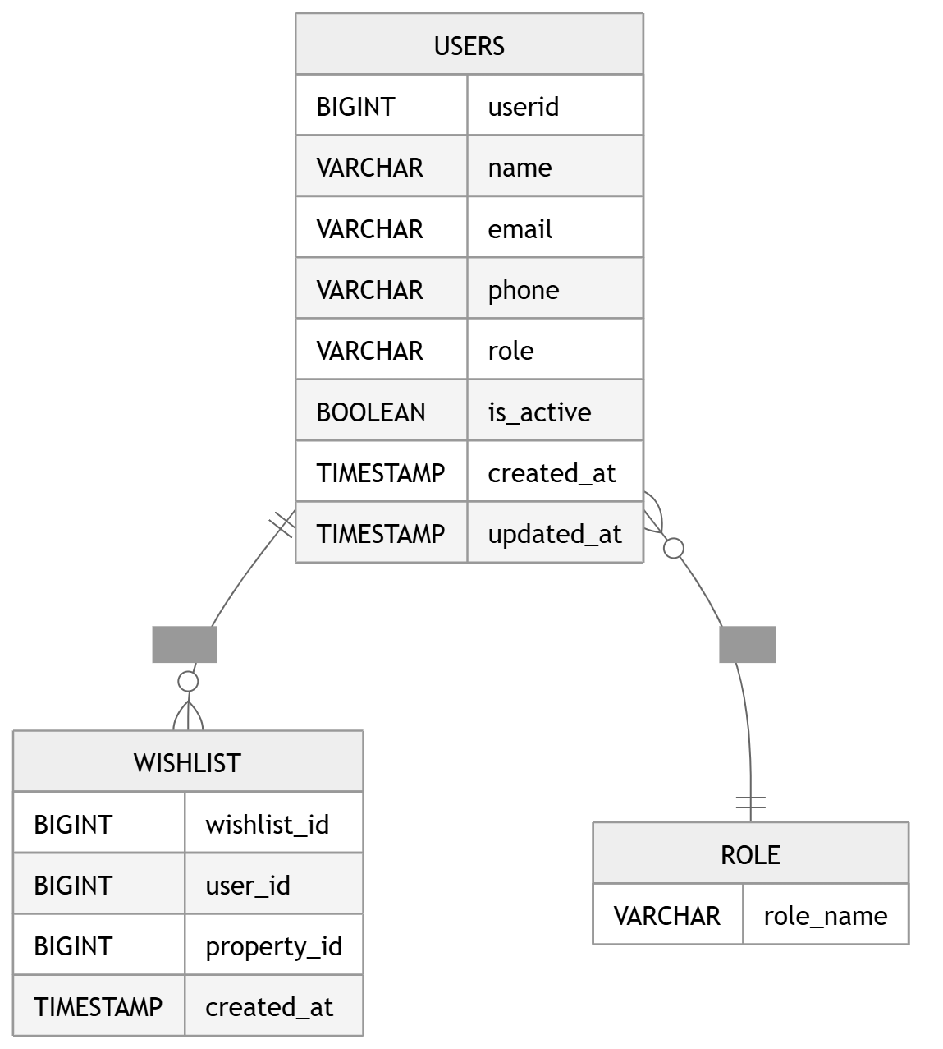

33.3 Owner Service ER Diagram
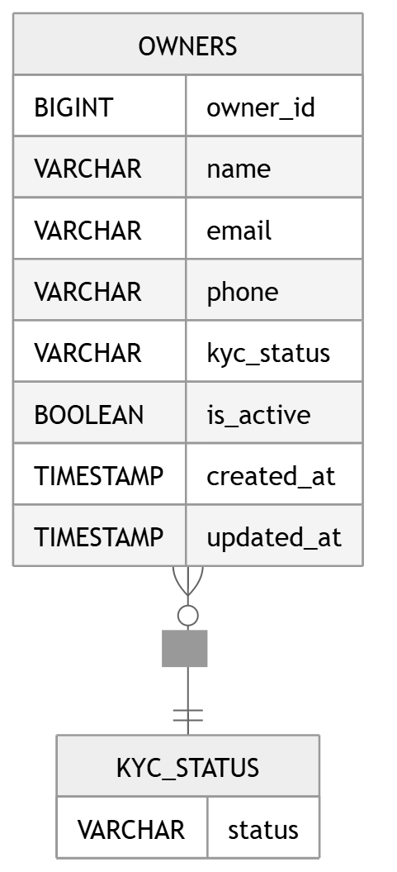

33.4 Property Service ER Diagram
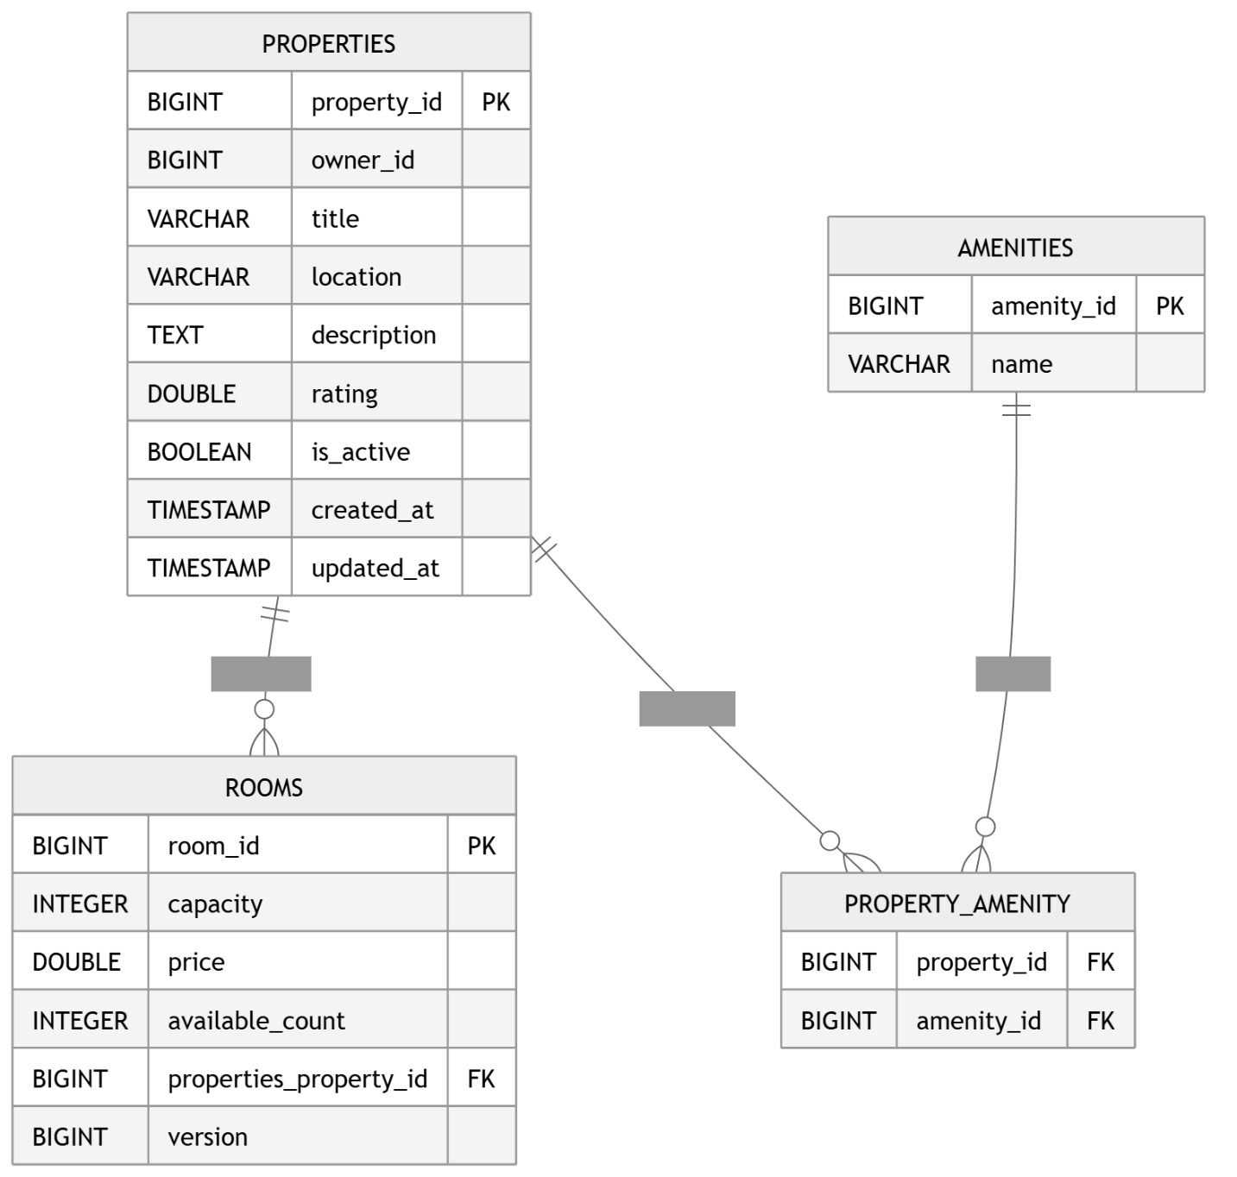

33.5 Booking Service ER Diagram
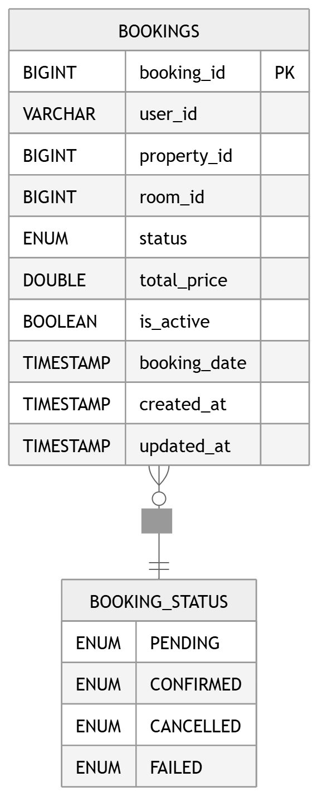

33.6 Payment Service ER Diagram
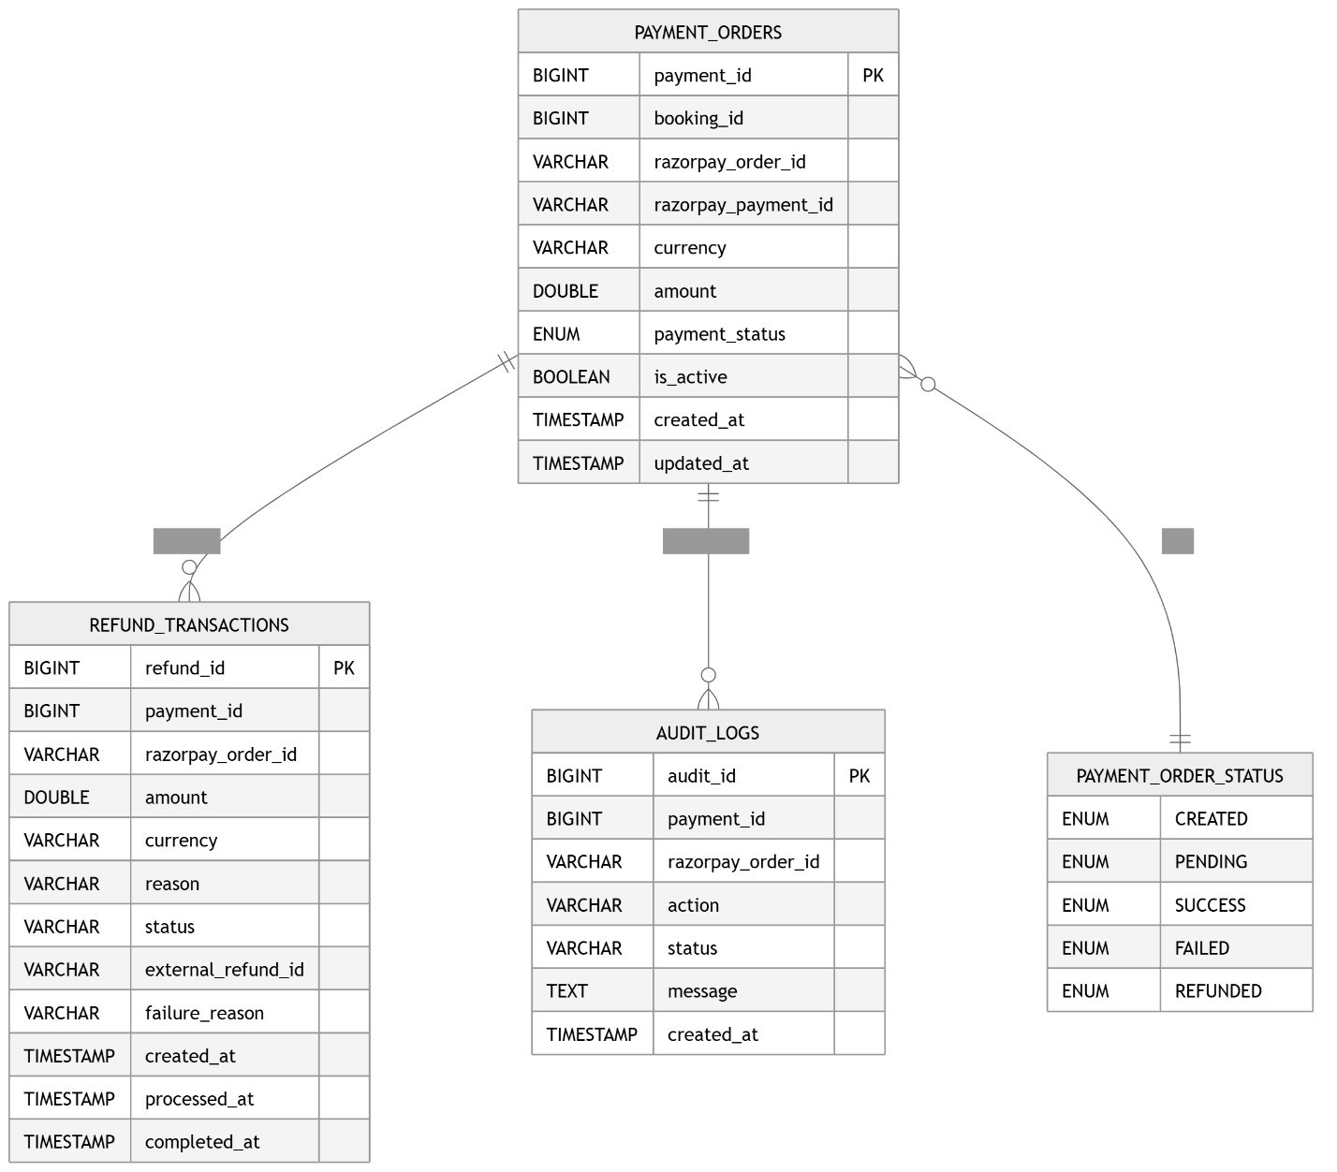

33.7 Notification Service ER Diagram
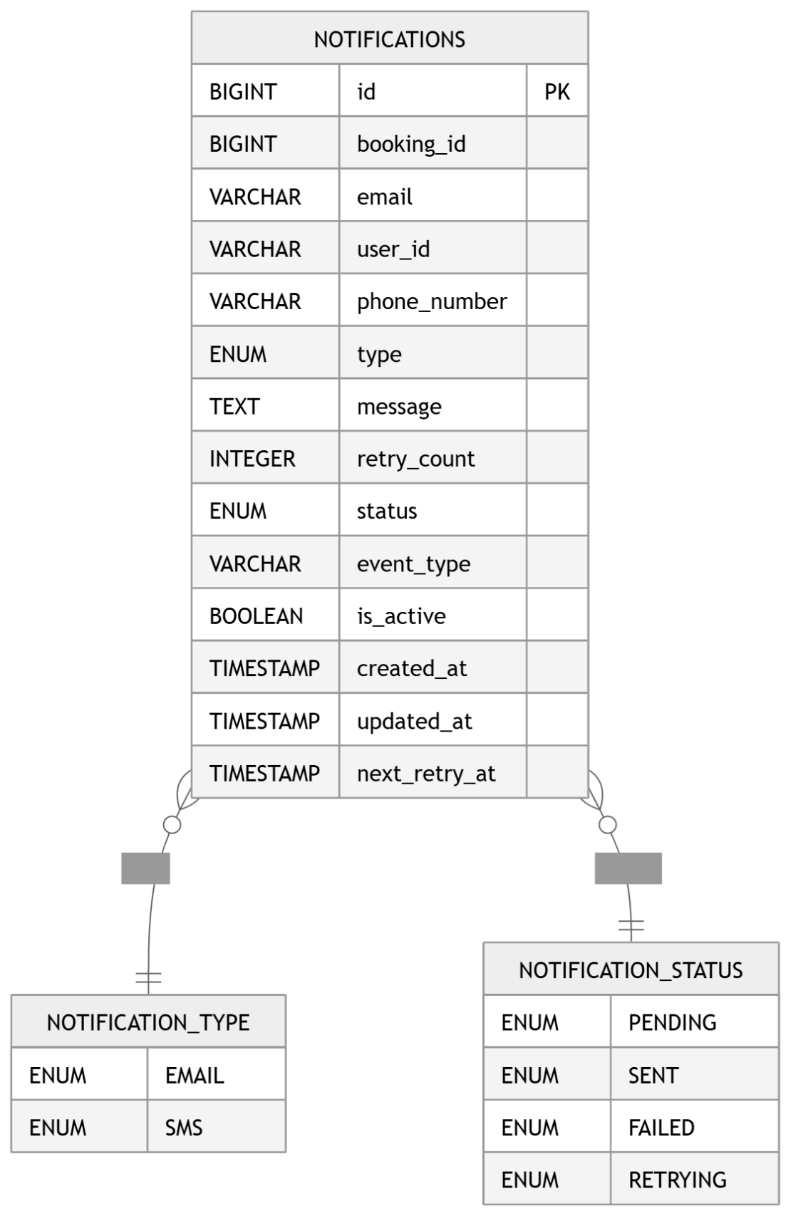

34. Final Enterprise Architecture Observation

Enterprise-Level Concepts Successfully Implemented
Concept | Present in Project
Microservices Architecture | Yes
API Gateway | Yes
JWT Security | Yes
OpenFeign Communication | Yes
Distributed Transaction Coordination | Yes
External Payment Integration | Yes
Async Processing | Yes
Retry Handling | Yes
Audit Logging | Yes
Webhook Architecture | Yes
Layered Architecture | Yes
DTO Separation | Yes
Global Exception Handling | Yes
Correlation ID Tracing | Yes
Enterprise Logging | Yes

35. Conclusion
StayEase is an enterprise-style distributed backend platform implementing modern backend engineering concepts using Java Spring Boot microservices.
The system successfully demonstrates:
- Distributed system design
- Service decomposition
- Payment integration
- Authentication & authorization
- Transaction orchestration
- Async processing
- RESTful API development
- Enterprise layering standards
- Extensible architecture principles
This project represents a strong practical implementation of modern Spring Boot microservices architecture suitable for enterprise-grade backend system demonstrations.

